**Interviewd Person 1: Suzal Choudhary**

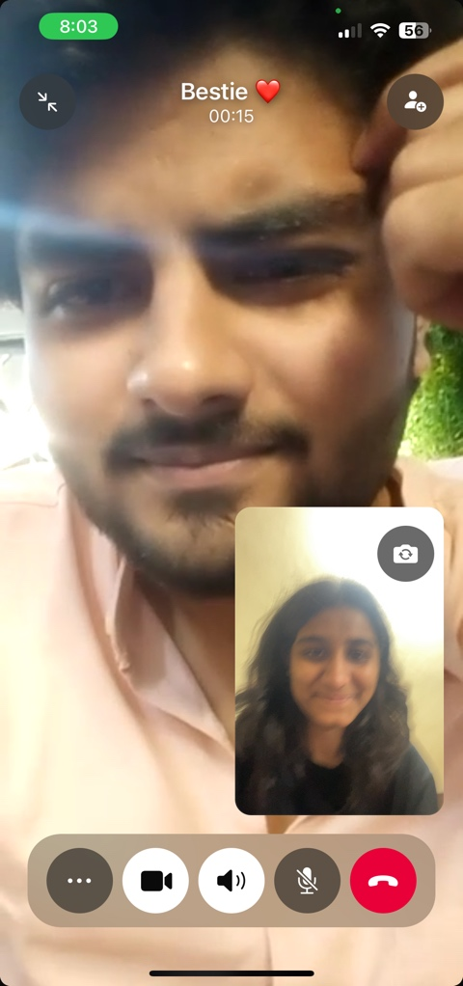

**General News Consumption**

1. **How often do you check the news online?**

* Moderately.

1. **What platforms do you use to get your news?**

* Dailyhunt.

1. **Do you prefer reading, watching, or listening to news?**

* Reading.

1. **Which news topics interest you most (e.g., politics, sports, entertainment)?**

* Sports, politics, and business.

1. **How do you find breaking news—social media, apps, or elsewhere?**

* TV channels and mobile apps.

**Platforms and Preferences**

1. **Why do you prefer certain platforms for news?**

* Easy to use and effective.

1. **Do you use global or local news sources more? Why?**

* Global mainly.

1. **Do you follow news on social media? Which platforms?**

* No.

1. **How often do you actively search for news vs. coming across it on social feeds?**

* I don’t follow any social media platform for news.

1. **How important is a news app/website’s design to you?**

* It’s crucial and important.

**Content Preferences**

**11. Do you prefer short summaries or detailed news articles?**

- Short.

**12. Do you like news that’s neutral or opinionated? Why?**

- Neutral, as it helps get the exact news.

**13. How much do videos or images in news stories matter to you?**

- Certainly important.

**14. How do you decide whether a news source is trustworthy?**

- Trusted application and platforms.

**15. Do you engage with comments or discussions on news stories?**

- No.

Information Overload and Trust

**16. Have you ever felt there’s too much news to keep up with?**

- Not necessarily.

**17. Do you trust the news sources you follow?**

Yes.

**18. Do you think some news platforms are biased? How does that affect your reading?**

Yes, for views and popularity, some platforms are biased.

**19. Have you encountered fake news? How do you verify if news is real?**

No.

**Personalization and Notifications**

**20. How do you feel about personalized news recommendations?**

**-** It’s a nice feature.

**21. Do you use notifications for news updates? Do you find them useful or annoying?**

No, because I feel it’s annoying.

**22.** **Do you think personalized news feeds can create an echo chamber?**

- I think so.

Paid Services

**23. Would you pay for ad-free or premium news services?**

- No.

**24. What features would make you pay for a news subscription?**

- I won’t.

**25. Do you think there’s a quality difference between free and paid news?**

- I don’t think so.

**Interviewed Person 2: Riddhi Rajawat**

**General News Consumption**

1. **How often do you check the news online?**

* Rarely.

1. **What platforms do you use to get your news?**

* Instagram and Twitter.

1. **Do you prefer reading, watching, or listening to news?**

* Watching short clips.

1. **Which news topics interest you most (e.g., politics, sports, entertainment)?**

* Entertainment and health.

1. **How do you find breaking news—social media, apps, or elsewhere?**

* Social media.

**Platforms and Preferences  
Why do you prefer certain platforms for news?**

* It’s quick and convenient**.**

1. **Do you use global or local news sources more? Why?**

* Local, for relevant updates.

1. **Do you follow news on social media? Which platforms?**

* Yes, mostly Instagram.

1. **How often do you actively search for news vs. coming across it on social feeds?**

* I come across it while scrolling.

1. **How important is a news app/website’s design to you?**

* Not really important.

**Content Preferences  
11. Do you prefer short summaries or detailed news articles?  
-** Short summaries. **12. Do you like news that’s neutral or opinionated? Why?  
-** Neutral.  
**13. How much do videos or images in news stories matter to you?  
-** They matter a lot. **14. How do you decide whether a news source is trustworthy?**- Based on the platform’s reputation. **15. Do you engage with comments or discussions on news stories?**- Sometimes.

**Information Overload and Trust  
16. Have you ever felt there’s too much news to keep up with?**- Yes, often.  
**17. Do you trust the news sources you follow?**- Somewhat. **18. Do you think some news platforms are biased? How does that affect your reading?**- Yes, many are. **19. Have you encountered fake news? How do you verify if news is real?**- Yes, many times.

**Personalization and Notifications  
20. How do you feel about personalized news recommendations?**- It’s useful sometimes.  
**21. Do you use notifications for news updates? Do you find them useful or annoying?**- No, they’re too distracting.  
**22. Do you think personalized news feeds can create an echo chamber?**- Definitely.

**Paid Services  
23. Would you pay for ad-free or premium news services?**- No, I wouldn’t.  
**24. What features would make you pay for a news subscription?**- None, I prefer free sources. **25. Do you think there’s a quality difference between free and paid news?**- Not really.

**Interviewd person 3: Shruti Chechani**

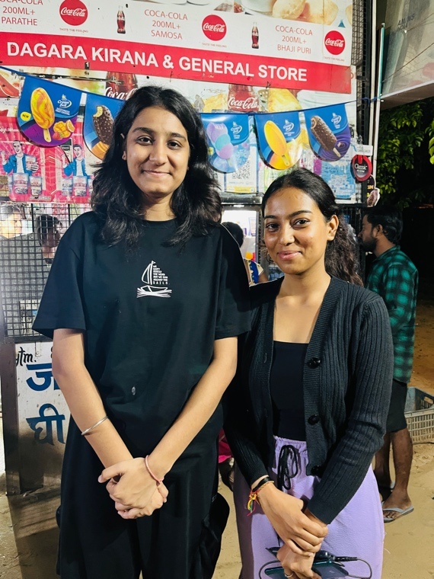

**General News Consumption**

1. **How often do you check the news online?**

* Once or twice a week.

1. **What platforms do you use to get your news?**

* Google News and Reddit.

1. **Do you prefer reading, watching, or listening to news?**

* Reading.

1. **Which news topics interest you most (e.g., politics, sports, entertainment)?**

* Technology and science.

1. **How do you find breaking news—social media, apps, or elsewhere?**

* Through notifications or browsing.

**Platforms and Preferences  
6. Why do you prefer certain platforms for news?**

* They give relevant updates quickly.

1. **Do you use global or local news sources more? Why?**

* Global, mostly.

1. **Do you follow news on social media? Which platforms?**

* Yes, on Twitter.

1. **How often do you actively search for news vs. coming across it on social feeds?**

* Sometimes, when there’s an interesting topic.

1. **How important is a news app/website’s design to you?**

* Not very important.

**Content Preferences  
11. Do you prefer short summaries or detailed news articles?**

* Detailed articles.

1. **Do you like news that’s neutral or opinionated? Why?**

* Neutral.

1. **How much do videos or images in news stories matter to you?**

* Not much.

1. **How do you decide whether a news source is trustworthy?**

* Cross-checking information with multiple sources**.**

1. **Do you engage with comments or discussions on news stories?**

* Rarely.

**Information Overload and Trust  
16. Have you ever felt there’s too much news to keep up with?**

* Yes, it’s overwhelming.

1. **Do you trust the news sources you follow?**

* Mostly.

1. **Do you think some news platforms are biased? How does that affect your reading?**

* Yes, especially in politics.

1. **Have you encountered fake news? How do you verify if news is real?**

* Yes, quite often.

**Personalization and Notifications  
20. How do you feel about personalized news recommendations?**

* It’s helpful.

1. **Do you use notifications for news updates? Do you find them useful or annoying?**

* Yes, but I limit them.

1. **Do you think personalized news feeds can create an echo chamber?**

* Yes, definitely.

**Paid Services  
23. Would you pay for ad-free or premium news services?**

* Maybe, if the service was worth it.

1. **What features would make you pay for a news subscription?**

* Exclusive articles and no ads.

1. **Do you think there’s a quality difference between free and paid news?**

* Yes, sometimes.

**Interviewed Person 4: Ankit Maheshwari**

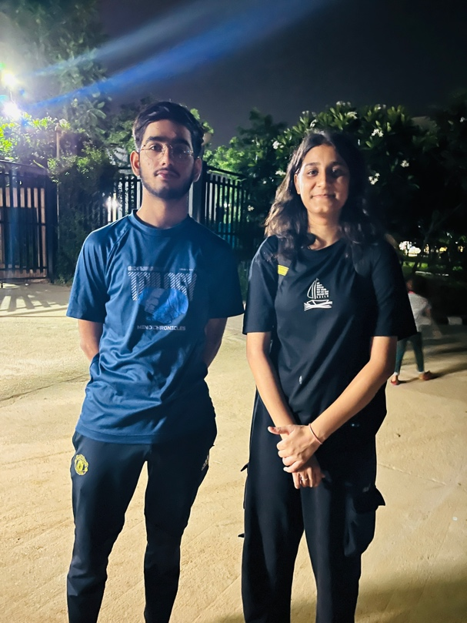

**General News Consumption**

**1. How often do you check the news online?**Hardly ever.

**2. What platforms do you use to get your news?**Sometimes Instagram, but not often.

**3. Do you prefer reading, watching, or listening to news?**I don’t really follow the news.

**4. Which news topics interest you most (e.g., politics, sports, entertainment)?**Entertainment, when I do check.

**5. How do you find breaking news—social media, apps, or elsewhere?**Usually through friends or social media.

**Platforms and Preferences  
6. Why do you prefer certain platforms for news?**I don’t really use any specific platform for news.

**7. Do you use global or local news sources more? Why?**Local, if at all, because it’s more relevant.

**8. Do you follow news on social media? Which platforms?**Sometimes on Instagram, but not regularly.

**9. How often do you actively search for news vs. coming across it on social feeds?**I just come across it while scrolling.

**10. How important is a news app/website’s design to you?**Not important at all.

**Content Preferences  
11. Do you prefer short summaries or detailed news articles?**Short summaries, if I’m interested.

**12. Do you like news that’s neutral or opinionated? Why?**Neutral, so it’s more reliable.

**13. How much do videos or images in news stories matter to you?**A lot, as I don’t read much.

**14. How do you decide whether a news source is trustworthy?**Based on word of mouth.

**15. Do you engage with comments or discussions on news stories?**No, I don’t.

**Information Overload and Trust  
16. Have you ever felt there’s too much news to keep up with?**Yes, it’s overwhelming.

**17. Do you trust the news sources you follow?**I don’t follow many.

**18. Do you think some news platforms are biased? How does that affect your reading?**Yes, that’s why I avoid it.

**19. Have you encountered fake news? How do you verify if news is real?**Not often, but I trust friends to verify.

**Personalization and Notifications  
20. How do you feel about personalized news recommendations?**I don’t need them.

**21. Do you use notifications for news updates? Do you find them useful or annoying?**Annoying, I turn them off.

**22. Do you think personalized news feeds can create an echo chamber?**I think so, yes.

**Paid Services  
23. Would you pay for ad-free or premium news services?**No, I wouldn’t.

**24. What features would make you pay for a news subscription?**None, I prefer free content.

**25. Do you think there’s a quality difference between free and paid news?**I’m not sure, as I don’t pay for news.

**Interviewed Person 5: Ram Singh Jaat  
  
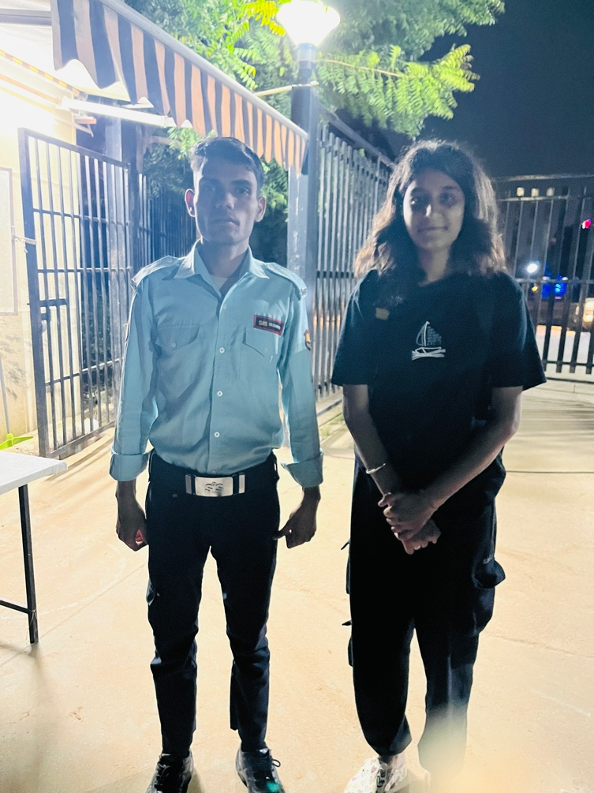**

**General News Consumption**

**1. How often do you check the news online?**I don’t check the news often.

**2. What platforms do you use to get your news?**I don’t have a regular platform.

**3. Do you prefer reading, watching, or listening to news?**None, I don’t follow the news much.

**4. Which news topics interest you most (e.g., politics, sports, entertainment)?**If anything, it would be sports.

**5. How do you find breaking news—social media, apps, or elsewhere?  
Sometimes through friends or random posts on social media.**

**Platforms and Preferences  
6. Why do you prefer certain platforms for news?**I don’t actively use any platforms.

**7. Do you use global or local news sources more? Why?**Neither, I don’t follow news regularly.

**8. Do you follow news on social media? Which platforms?**I come across it on Instagram occasionally.

**9. How often do you actively search for news vs. coming across it on social feeds?**I never search for news, I only come across it.

**10. How important is a news app/website’s design to you?**Not relevant to me.

**Information Overload and Trust  
16. Have you ever felt there’s too much news to keep up with?**Yes, that’s why I avoid it.

**17. Do you trust the news sources you follow?**I don’t follow any specific sources.

**18. Do you think some news platforms are biased? How does that affect your reading?**Probably, but since I don’t follow them, it doesn’t bother me.

**Personalization and Notifications  
20. How do you feel about personalized news recommendations?**I don’t need them.

**21. Do you use notifications for news updates? Do you find them useful or annoying?**I find them annoying, so I don’t use them.

**22. Do you think personalized news feeds can create an echo chamber?**Probably, but I don’t follow them enough to care

**Interviewed Person 6: Archana Joshi**

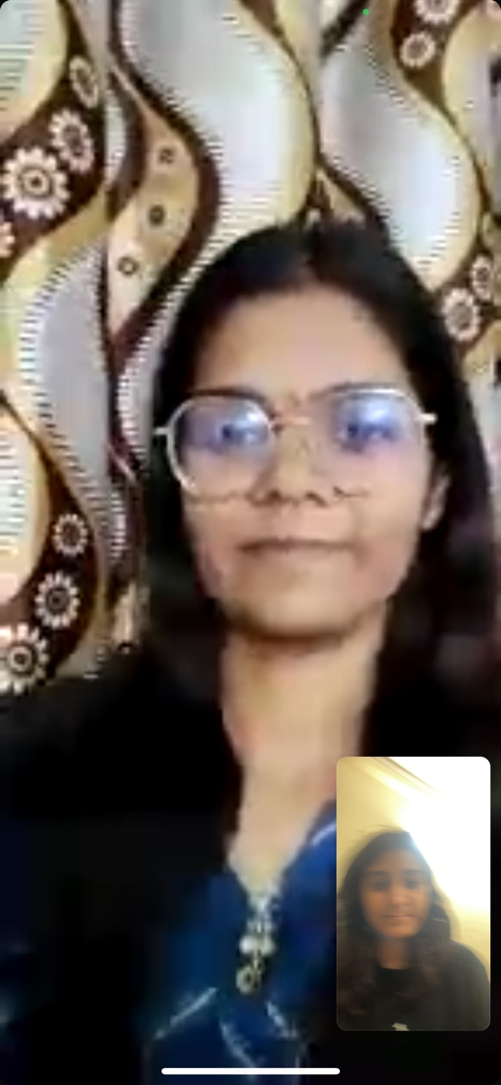

**General News Consumption**

**1. How often do you check the news online?**  
A few times a day to stay updated on both work-related and general news.

**2. What platforms do you use to get your news?**  
I use BBC, CNN, The Guardian, Google News, Twitter, and LinkedIn for updates.

**3. Do you prefer reading, watching, or listening to news?**  
I prefer reading, but I also watch videos or listen to podcasts sometimes.

**4. Which news topics interest you most (e.g., politics, sports, entertainment)?**  
Politics and technology.

**5. How do you find breaking news—social media, apps, or elsewhere?**  
Social media like Twitter and notifications from Google News and other apps.

**Platforms and Preferences**

**6. Why do you prefer certain platforms for news?**I like platforms that are fast, reliable, and easy to use, like Google News and Twitter.

**7. Do you use global or local news sources more? Why?**I use both—global for international events and local to stay connected to my community.

**8. Do you follow news on social media? Which platforms?**Yes, mainly Twitter and LinkedIn.

**9. How often do you actively search for news vs. coming across it on social feeds?**I actively search when I need detailed information, but I also come across news on social feeds.

**10. How important is a news app/website’s design to you?**It’s important for ease of use and readability.

**Content Preferences  
11. Do you prefer short summaries or detailed news articles?**Detailed articles for in-depth understanding.

**12. Do you like news that’s neutral or opinionated? Why?**Neutral, as it provides a more balanced view.

**13. How much do videos or images in news stories matter to you?**They are helpful for better understanding and engagement.

**14. How do you decide whether a news source is trustworthy?**I check the source’s reputation and cross-reference with other reliable sources.

**15. Do you engage with comments or discussions on news stories?**Occasionally, to see different perspectives.

**Information Overload and Trust  
16. Have you ever felt there’s too much news to keep up with?**Yes, it can be overwhelming at times.

**17. Do you trust the news sources you follow?**Generally, yes, but I verify information when in doubt**.**

**18. Do you think some news platforms are biased? How does that affect your reading?**Yes, some are biased, which is why I cross-check news from multiple sources.

**19. Have you encountered fake news? How do you verify if news is real?**Yes, I verify by checking multiple reputable sources and fact-checking websites.

**Personalization and Notifications  
20. How do you feel about personalized news recommendations?**They are useful for getting relevant updates.

**21. Do you use notifications for news updates? Do you find them useful or annoying?**Useful, as they keep me informed in real-time.

**22. Do you think personalized news feeds can create an echo chamber?**Yes, if not balanced with diverse sources.

**Paid Services  
23. Would you pay for ad-free or premium news services?**Yes, if the service offers exclusive content and no ads.

**24. What features would make you pay for a news subscription?**High-quality journalism, ad-free experience, and exclusive reports.

**25. Do you think there’s a quality difference between free and paid news?**Yes, paid news often has better investigative reporting and fewer ads.

**Interviewed person 7: Sneha jain**

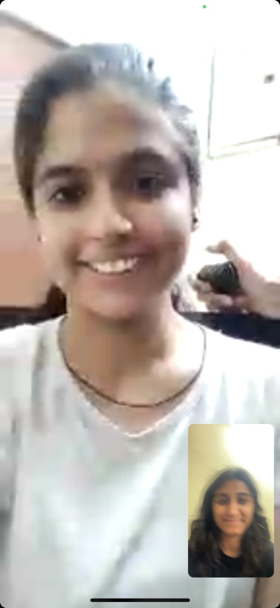

**General News Consumption**

**1. How often do you check the news online?**Rarely, maybe once a week.

**2. What platforms do you use to get your news?**Occasionally Facebook and Google News.

**3. Do you prefer reading, watching, or listening to news?**Reading when I do check the news.

**4. Which news topics interest you most (e.g., politics, sports, entertainment)?**Entertainment and lifestyle.

**5. How do you find breaking news—social media, apps, or elsewhere?**Mostly social media from friends or family.

**Platforms and Preferences  
6. Why do you prefer certain platforms for news?**I don’t have a strong preference; I use whatever is available.

**7. Do you use global or local news sources more? Why?**Local, for community updates.

**8. Do you follow news on social media? Which platforms?**Occasionally on Facebook.

**9. How often do you actively search for news vs. coming across it on social feeds?**I mostly come across it by chance.

**10. How important is a news app/website’s design to you?**Not very important.

**Content Preferences  
11. Do you prefer short summaries or detailed news articles?**Short summaries.

**12. Do you like news that’s neutral or opinionated? Why?**Neutral, for a clearer picture.

**13. How much do videos or images in news stories matter to you?**Somewhat, they make the news more engaging.

**14. How do you decide whether a news source is trustworthy?**I rely on recommendations from friends.

**15. Do you engage with comments or discussions on news stories?**Rarely.

**Information Overload and Trust  
16. Have you ever felt there’s too much news to keep up with?**Yes, it’s overwhelming.

**17. Do you trust the news sources you follow?**Generally, but I don’t follow many.

**18. Do you think some news platforms are biased? How does that affect your reading?**Yes, which is why I avoid them.

**19. Have you encountered fake news? How do you verify if news is real?**Sometimes, I check multiple sources to verify.

**Personalization and Notifications  
20. How do you feel about personalized news recommendations?**I’m indifferent; I don’t use them much.

**21. Do you use notifications for news updates? Do you find them useful or annoying?**Annoying, so I keep them turned off.

**22. Do you think personalized news feeds can create an echo chamber?**Possibly, if not balanced with different sources.

**Paid Services  
23. Would you pay for ad-free or premium news services?**No, I prefer free options.

**24. What features would make you pay for a news subscription?**Exclusive content and in-depth articles.

**25. Do you think there’s a quality difference between free and paid news?**Yes, generally paid news is more comprehensive.

**Interviewed Person 8: Saurav Yadav**

**General News Consumption**

**1. How often do you check the news online?**Daily, to stay updated.

**2. What platforms do you use to get your news?**BBC, Al Jazeera, and news apps.

**3. Do you prefer reading, watching, or listening to news?**I prefer reading, but I also watch news on TV.

**4. Which news topics interest you most (e.g., politics, sports, entertainment)?**Politics and global events.

**5. How do you find breaking news—social media, apps, or elsewhere?**Through apps and news websites.

**Platforms and Preferences**

**6. Why do you prefer certain platforms for news?**They offer reliable and timely updates.

**7. Do you use global or local news sources more? Why?**Global, for a broader perspective.

**8. Do you follow news on social media? Which platforms?**Yes, mainly Twitter and Facebook.

**9. How often do you actively search for news vs. coming across it on social feeds?**I actively search for specific updates.

**10. How important is a news app/website’s design to you?**Important for usability and readability.

**Content Preferences  
11. Do you prefer short summaries or detailed news articles?**Detailed articles for in-depth information.

**12. Do you like news that’s neutral or opinionated? Why?**Neutral, for unbiased information.

**13. How much do videos or images in news stories matter to you?**They enhance the story but are not essential.

**14. How do you decide whether a news source is trustworthy?**By checking its reputation and cross-referencing with other sources.

**15. Do you engage with comments or discussions on news stories?**Sometimes, to understand different viewpoints.

**Information Overload and Trust**

**16. Have you ever felt there’s too much news to keep up with?**Yes, it can be overwhelming.

**17. Do you trust the news sources you follow?**Mostly, but I always verify important information.

**18. Do you think some news platforms are biased? How does that affect your reading?**Yes, which is why I use multiple sources.

**19. Have you encountered fake news? How do you verify if news is real?**Yes, I cross-check with reliable sources.

**Personalization and Notifications  
20. How do you feel about personalized news recommendations?**They are helpful for relevant updates.

**21. Do you use notifications for news updates? Do you find them useful or annoying?**Useful, as they keep me informed.

**22. Do you think personalized news feeds can create an echo chamber?**Yes, it can limit exposure to diverse views.

**Paid Services**

**23. Would you pay for ad-free or premium news services?**Yes, if it offers quality content and no ads.

**24. What features would make you pay for a news subscription?**Exclusive content and in-depth analysis.

**25. Do you think there’s a quality difference between free and paid news?**Yes, paid news often provides more detailed reporting.

**Interviewed Person 9: DK Pandit**

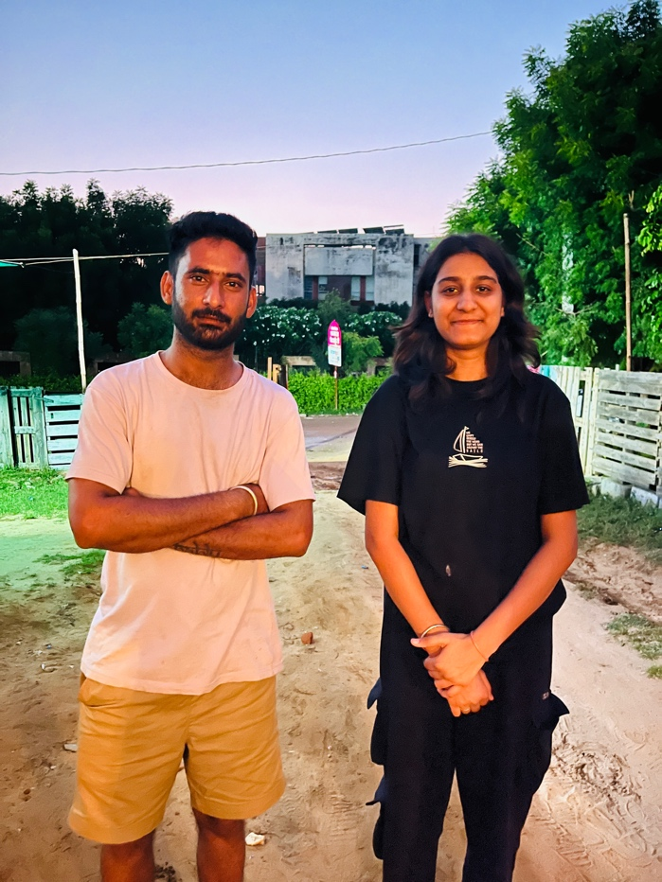

**General News Consumption**

**1. How often do you check the news online?**Occasionally, maybe once a week.

**2. What platforms do you use to get your news?**I use random news websites when I have time.

**3. Do you prefer reading, watching, or listening to news?**I don’t follow news regularly.

**4. Which news topics interest you most (e.g., politics, sports, entertainment)?**I’m not very interested in news.

**5. How do you find breaking news—social media, apps, or elsewhere?**I might see it on social media, but I don’t actively look for it.

**Platforms and Preferences  
6. Why do you prefer certain platforms for news?**I don’t have a preference; I rarely use news platforms.

**7. Do you use global or local news sources more? Why?**I don’t use news sources regularly.

**8. Do you follow news on social media? Which platforms?**Sometimes on Facebook, but not often.

**9. How often do you actively search for news vs. coming across it on social feeds?**I mostly come across news by accident.

**10. How important is a news app/website’s design to you?**Not important to me.

**Content Preferences  
11. Do you prefer short summaries or detailed news articles?**I don’t have a preference since I don’t read news often.

**12. Do you like news that’s neutral or opinionated? Why?**Neutral, if I ever do read news.

**13. How much do videos or images in news stories matter to you?**Not much, as I don’t follow news actively.

**14. How do you decide whether a news source is trustworthy?**I rely on what others tell me.

**15. Do you engage with comments or discussions on news stories?**Rarely, if ever.

**Information Overload and Trust  
16. Have you ever felt there’s too much news to keep up with?**Yes, that’s why I don’t keep up with it.

**17. Do you trust the news sources you follow?**I don’t follow many news sources.

**18. Do you think some news platforms are biased? How does that affect your reading?**I think they might be, but it doesn’t affect me much since I don’t read news regularly.

**19. Have you encountered fake news? How do you verify if news is real?**I haven’t paid much attention, so I haven’t verified much.

**Personalization and Notifications  
20. How do you feel about personalized news recommendations?**I don’t use them.

**21. Do you use notifications for news updates? Do you find them useful or annoying?**I don’t use notifications for news.

**22. Do you think personalized news feeds can create an echo chamber?**I wouldn’t know, since I don’t use them.

**Paid Services  
23. Would you pay for ad-free or premium news services?**No, I don’t follow news enough to pay for it.

**24. What features would make you pay for a news subscription?**I wouldn’t pay for it.

**25. Do you think there’s a quality difference between free and paid news?**I don’t have a strong opinion since I don’t follow news closely.

**Interviwed Person 10: Anand Gupta**



**General News Consumption**

**1. How often do you check the news online?**Almost never.

**2. What platforms do you use to get your news?**I don’t use any specific platforms for news.

**3. Do you prefer reading, watching, or listening to news?**I don’t follow the news at all.

**4. Which news topics interest you most (e.g., politics, sports, entertainment)?**I’m not really interested in news topics.

**5. How do you find breaking news—social media, apps, or elsewhere?**I rarely find breaking news; if I do, it’s usually from conversations with others.

**Platforms and Preferences  
6. Why do you prefer certain platforms for news?**I don’t have a preference since I don’t follow the news.

**7. Do you use global or local news sources more? Why?**I don’t use news sources at all.

**8. Do you follow news on social media? Which platforms?**No, I don’t follow news on social media.

**9. How often do you actively search for news vs. coming across it on social feeds?**I never actively search for news and rarely come across it.

**10. How important is a news app/website’s design to you?**It’s not important since I don’t use news apps or websites.

**Content Preferences  
11. Do you prefer short summaries or detailed news articles?**I don’t have a preference because I don’t read news.

**12. Do you like news that’s neutral or opinionated? Why?**I don’t have a preference since I don’t read news.

**13. How much do videos or images in news stories matter to you?**They don’t matter to me because I don’t follow news.

**14. How do you decide whether a news source is trustworthy?**I don’t make decisions about news sources because I don’t follow the news.

**15. Do you engage with comments or discussions on news stories?**No, I don’t engage with news stories.

**Information Overload and Trust  
16. Have you ever felt there’s too much news to keep up with?**Not really, since I don’t keep up with the news.

**17. Do you trust the news sources you follow?**I don’t follow any news sources.

**18. Do you think some news platforms are biased? How does that affect your reading?**I think they might be, but it doesn’t affect me as I don’t read the news.

**19. Have you encountered fake news? How do you verify if news is real?**I haven’t encountered fake news because I don’t follow the news.

**Personalization and Notifications  
20. How do you feel about personalized news recommendations?**I don’t use them.

**21. Do you use notifications for news updates? Do you find them useful or annoying?**I don’t use notifications for news updates.

**22. Do you think personalized news feeds can create an echo chamber?**I wouldn’t know since I don’t use them**.**

**Paid Services  
23. Would you pay for ad-free or premium news services?**No, I don’t follow the news enough to consider paying for it**.**

**24. What features would make you pay for a news subscription?**I wouldn’t pay for a news subscription.

**25. Do you think there’s a quality difference between free and paid news?**I don’t have an opinion since I don’t follow news.